## Shapes

**NOTE**: You need a public StartUp class with the namespace Shapes.

Build a **hierarchy** of **interfaces** and **classes**:

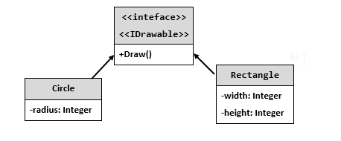

You should be able to use the class like this:

|  |
| --- |
| StartUp.cs |
| var radius = int.Parse(Console.ReadLine());  IDrawable circle = new Circle(radius);  var width = int.Parse(Console.ReadLine());  var height = int.Parse(Console.ReadLine());  IDrawable rect = new Rectangle(width, height);  circle.Draw();  rect.Draw(); |

### Examples

|  |  |
| --- | --- |
| **Input** | **Output** |
| 3  4  5 | *******  ** **  ** **  * *  ** **  ** **  *******  ****  * *  * *  * *  **** |